Post Man

Activity

1. **GET operation for sold pets.**

Base URL: https://petstore.swagger.io/v2/pet/findByStatus

URL: <https://petstore.swagger.io/v2/pet/findByStatus?status=sold>

[

    {

        "id": 822922,

        "category": {

            "id": -69794609,

            "name": "irure laborum id proident incididunt"

        },

        "name": "doggie",

        "photoUrls": [

            "dolore ipsum qui",

            "fugiat non eiusmod Duis nisi"

        ],

        "tags": [

            {

                "id": -24720491,

                "name": "nisi"

            },

            {

                "id": 87603503,

                "name": "ut sint enim cillum nisi"

            }

        ],

        "status": "sold"

    }

]

**Data count = 1**

1. **Add new pet using IBM id (last four digits), give name , give creative status rather than sold, unsold etc..**

**Base URL:** https://petstore.swagger.io/v2/pet

**POST request to add new data**

**Send the request and save to store, then retrieve the data using ID and parameters**

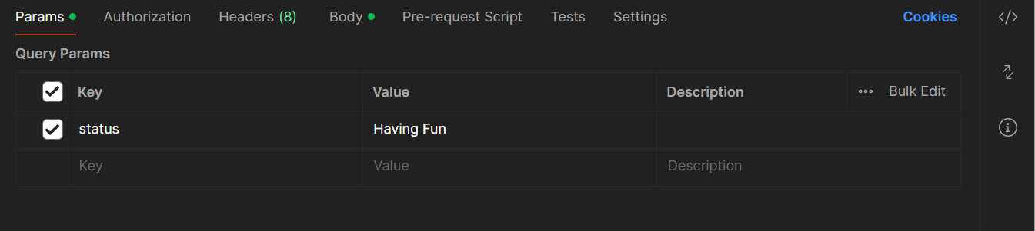

**URL:** https://petstore.swagger.io/v2/pet/findByStatus?status=Having Fun

[

    {

        "id": 15,

        "category": {

            "id": 0,

            "name": "string"

        },

        "name": "Sandy",

        "photoUrls": [

            "string"

        ],

        "tags": [

            {

                "id": 0,

                "name": "string"

            }

        ],

        "status": "Having Fun"

    }

]

**3.Add a pet as above but randomize the pet name as well as the pet status based on a predifined set of values.**

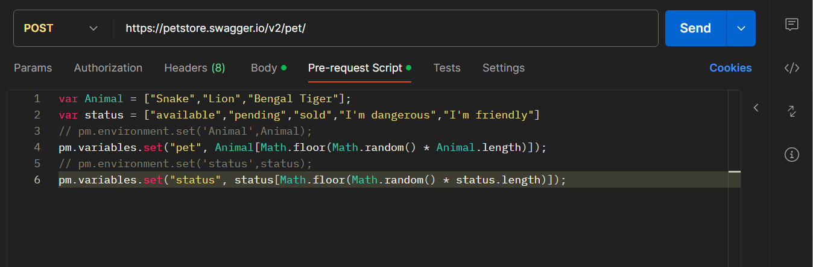

**Every time we do POST request the values of name and status changes.**